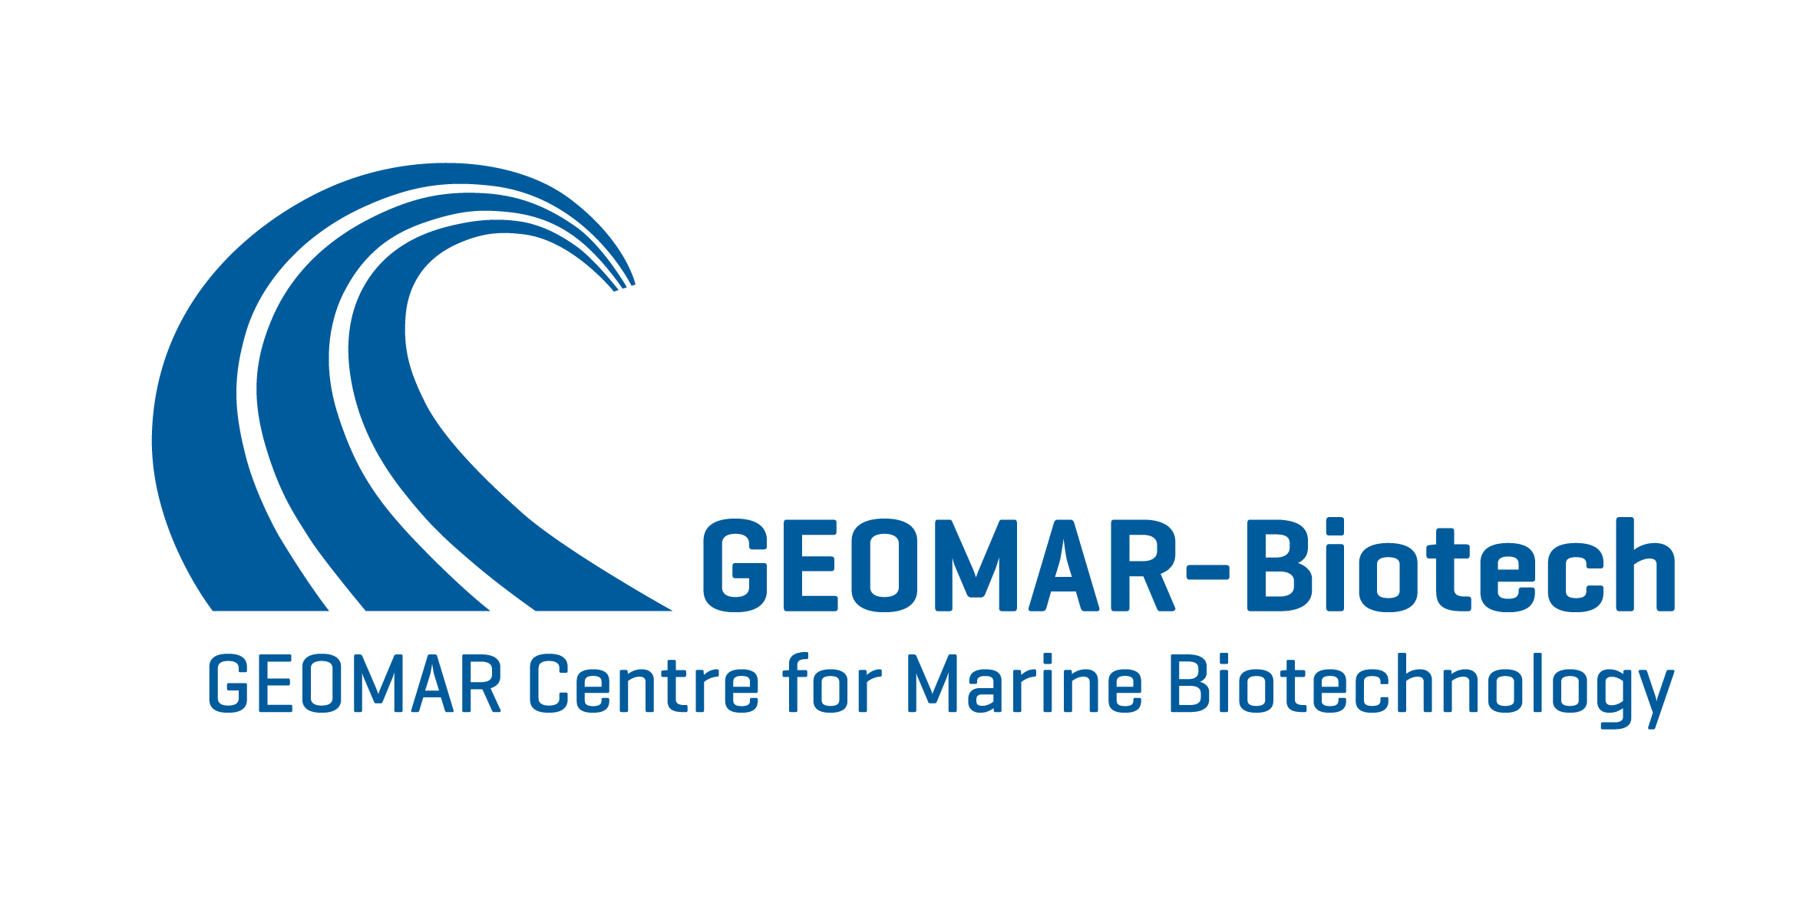

2. International Conference of Marine Fungal Natural Products (MaFNaP_2017), 27-29 June 2017, Kiel, Germany
Abstract submission

☐ Abstract to be considered as short talk
☐ Abstract to be considered as poster
Abstract template

Abstract Title (Bold, Arial 12pt, maximum two lines)

Presenting author’s full name,¹ co-author’s full name², … (Arial 11pt, underline the presenting author), e.g.:
Martina Blümel,¹ Bettina Reuter¹, John Smith,² Deniz Tasdemir¹
¹Affiliation of the first author, ² Affiliation of the co-author (Arial 11pt)

Leave blank space (12pt) before abstract text

Abstract body text (Arial 12pt) should be no longer than 250 words.
You may insert small tables, chemical structures, or figures as long as the abstract fits to one single A4 page.
For references in the abstract text, use numbers in brackets e.g. [1] and [1,2] etc..
Leave blank space (12 pt) before References

References (Arial 11pt)
[1] Dodd, L.G. et al., Am. J. Clin. Pathol. 1990; 93:141-144.

Complete your abstract, save under your last name and send electronically -as a Word file- to Martina Blümel (mbluemel@geomar.de) before May 1, 2017.
Please put ‘MaFNaP_2017_abstract_your name_poster_OR_talk’ into the subject line of your email!
EXTENDED Abstract submission deadline: May 1, 2017

